Romero:
25 Years Later
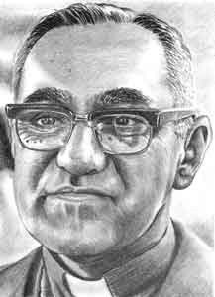
Join us…
For a community celebration of the legacy of Salvadoran Oscar Romero

Saturday, April 2, 2005

11:00 a.m. Ecumenical Service at Our Lady of Guadalupe Church
(9th & Lydia), then march to

12:00 p.m. Community Open Forum, PanAm Hillside Theatre
(2100 E 3rd, behind Zavala Elementary)

Speakers Music Food Poetry
Bring blankets or chairs!

Special Guest: Marta Benavides - Ms. Benavides is a Salvadoran activist, theologian and educator. She worked with Monsignor Oscar Romero directing the Ecumenical Humanitarian Aid program, started the refugee centers in El Salvador, and developed campaigns to stop the war and defend human rights. Ms. Benavides will be sharing her experiences with M. Romero and speaking on her work in creating conditions to assure that rural and urban peoples practice cooperation and governance, respect and care for the planet, and go from the signed peace to living peace.
Also, don’t miss this great event!
Musical Homage to Romero

March 24, 2005
8:00 p.m. – 12:30 a.m.
Ruta Maya (3601 S. Congress)

Music by Nelson Saga & Arma del Alma, Mauricio Ramos Callejas, Gustavo Rodríguez Band, and many more!

$5 suggested donation at the door. Proceeds benefit the Foundation for Self-Sufficiency in Central America. Call (512) 388-7957 for more info.

Sponsored by: American Friends Service Committee, Casa Marianella,
Rhizome Collective, SOAW Austin

Questions? Visit SOAW-Austin.org/romero. Email amandajack@gmail.com or call AFSC at (512) 474-2399

